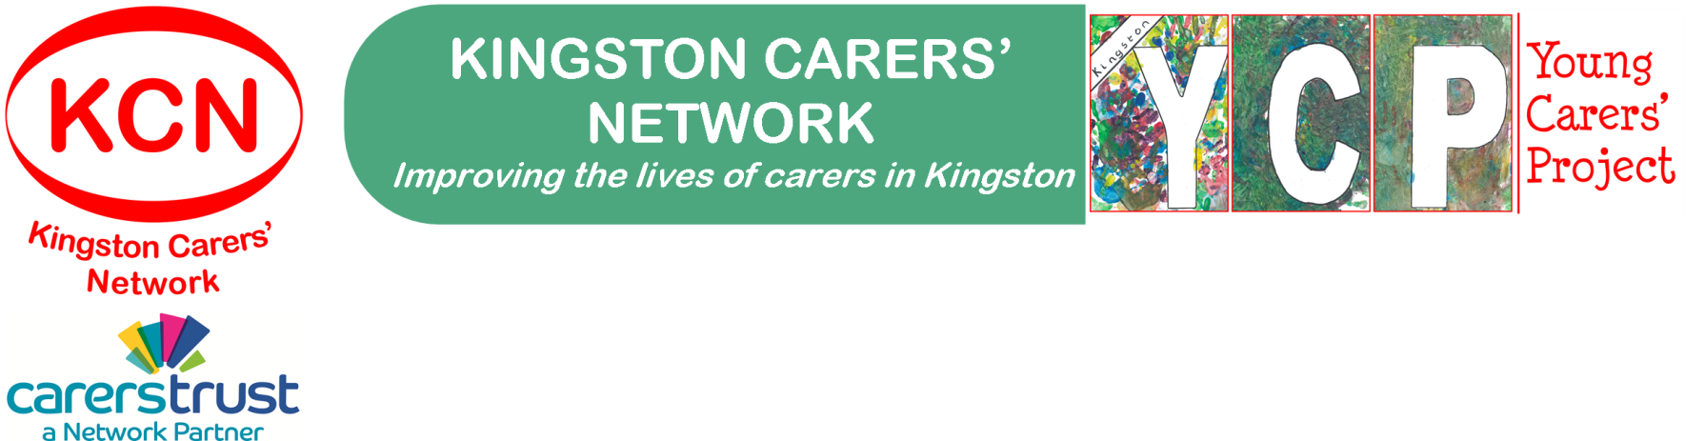

Young Carer Mentor – Application Form

Thank you for your interest in our mentoring project, to get the process started we would like to find out more about you.
The information that you provide on this form will be handled and stored in accordance with current Data Protection legislation.
Personal Information
Title (Mr/Mrs/Miss/Ms/Other)
Name
Home Address
Post Code
Contact Phone No
Email Address
Date of Birth
Emergency Contact (name & number)
How did you hear about our mentoring project?
What times during the day can we contact you?

Your experience
Please give brief details of your work/life experience:

Do you have any previous volunteering experience? If yes please give brief details

Is there anything you wish to disclose that would help us to support you in your volunteering, such as a health problem or disability?

Your motivation
Why are you interested in mentoring a young carer?
What skills/experience do you feel you have to offer as a mentor?
What challenges do you think you may encounter through mentoring?
What would you like to get out of your volunteering experience?
Are you able to commit to 6-12 months of mentoring? Including meeting with a young carer once a fortnight?

References
Please can you give the names and addresses of 2 people (not relatives), who would be willing to act as referees. One must be a current or recent employer, school, college or university teacher. The other can be someone who has known you in a personal capacity for at least two years
Referee 1
Name
Address
Post Code
Occupation
Contact No
Email Address
How long have you known the person?
In what capacity do you know this person?

Referee 2
Name
Address
Post Code
Occupation
Contact No
Email Address
How long have you known the person?
In what capacity do you know this person?

Disclosure and Barring Check
Due to the nature of the volunteering which involves regular one to one contact with children or young people, an enhanced Disclosure with a check on the barred list is required.
Are you willing to undergo such a check? YES / NO

The Rehabilitation of offenders Act 1974 (Exceptions) Order 1975 (Exceptions)(Amendment) Order 1986

Due to the nature of the volunteering this role is exempt under the Rehabilitation of Offenders Act 1974 and you are required to reveal all convictions, even those which are spent.

Have you have been convicted of any criminal offences, cautions or charges pending?

YES NO

If so please provide details in a separate sealed envelope.

Please note that convictions for offences do not necessarily debar an applicant from a volunteer position.

Data Protection

Kingston Carers’ Network keeps a confidential database for administrative purposes. No personal information relating to this recruitment is divulged except to third parties such as referees. It will be held as long as you volunteer and for 6 months after leaving.

Will you allow your details to be held by KCN this way? YES NO

Declaration

I certify that the information that I have given is true & correct to the best of my knowledge & belief and understand that giving false or misleading statements or withholding information may result in the withdrawal of your volunteer role.

Signature Date

Please email form to: volunteering@kingstoncarers.org.uk or post to: Volunteer coordinator, Kingston Carers Network, The Noble Centre, 109a Blagdon Road, New Malden, Surrey, KT3 4BD

