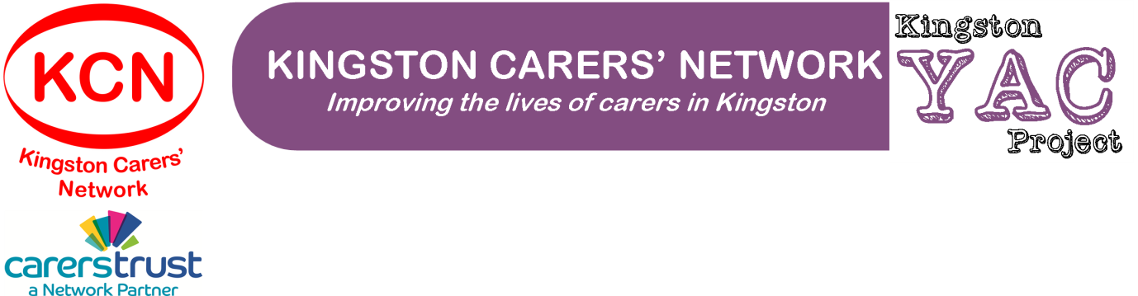

Self-Referral to Kingston Carers’ Network – Young Adult Carers’ Project
Your Details
Full name: |  | Date of birth:
Address: |  | Home telephone:  Mobile telephone:  Email:
Name of your main guardian (if applicable): |  | Relationship to you:
Address of main guardian, if different from your address: |  | Your main guardian’s:  Home telephone:  Mobile telephone:  Email:
Carer’s School, College or University (if applicable): |  | Is your school, college or university aware of your caring situation? (Please tick)  YES  NO  DON’T KNOW
School, College or University contact person (if applicable): |  | Contact telephone:  Contact email:
Ethnicity (please tick):
White |  | Mixed/Multiple Ethnic Groups
English/Welsh/Scottish/Northern Irish/British |  | White and Black Caribbean
Irish |  | White and Black African
Gypsy/Roma |  | White and Asian
Irish Traveller |  | Any other mixed/multiple ethnic background
Any other White background
 |  | Asian/Asian British
Black/African/Caribbean/Black British |  | Indian
African |  | Pakistani
Caribbean |  | Bangladeshi
Any other Black/African/Caribbean background |  | Chinese
 |  | Any other Asian background
Other Ethnic Group
Arab |  | Prefer not to say
Any other ethnic group

The person you look after
Full name: | Date of birth:
Address (if different from your address): | Relationship to you:
Diagnosis / Nature of condition: | Nature of help you provide:

Additional information about you
Please provide details of any other relevant information about you (e.g. allergies, medication, health needs, access needs)

Additional information – your family circumstances
Please provide details of any other relevant information about your family context (e.g. who else lives at home, other support currently in place or that has just recently ended)

Please send this form to yac@kingstoncarers.org.uk or by post to Emma Bell at Kingston Carers’ Network, The Noble Centre, 109a Blagdon Road, New Malden, Surrey, KT3 4BD

